# Anti-Bullying Policy

## Purposes:

* To ensure every child is able to learn in a school environment free from bullying of any kind and in which they feel safe and supported
* To educate students about the meaning of respect for others and nurture an ethos within the school in which bullying is rejected by the vast majority of students and incidents reported to staff when they occur
* To provide support for targets of bullying and those who bully as well as their parents/carers
* To ensure that the Public Sector Equality Duty (PSED) is maintained in order to:-
* Eliminate unlawful discrimination and other conduct that is prohibited by the 2010 Equality Act;
* Advance equality of opportunity between people who share a protected characteristic and people who do not;
* Foster good relations between people who share a protected characteristic and people who do not share it.

|  |  |
| --- | --- |
| Reviewed | RRC |
| Governor Committee | Local Governing Body |
| Ratification date by Governors | Summer 2025 |
| Review Due | Summer 2027 |

# What is bullying?

* There is no legal definition of bullying however the Government defines bullying as:

**“Behaviour by an individual or group, usually repeated over time, that**

**intentionally hurts another individual or group either physically or emotionally”**

Bullying of any kind is unacceptable at Taverham High School. If bullying does occur, all students should be able to report incidents and know that these will be dealt with promptly and effectively. This means that anyone who knows that bullying is happening is expected to inform a member of staff.

Bullying is a form of abuse. It is a persistent, deliberate attempt to hurt or humiliate someone. There are various types of bullying, but most have three things in common:

* it is deliberately hurtful behaviour
* it is repeated over time
* there is an imbalance of power, which makes it hard for those being bullied to defend themselves.

Bullying takes many different forms, but the four main types are:

* physical – including hitting, kicking, stealing of possessions
* verbal – name calling, sexual/racist/homophobic/biphobic/transphobic remarks, insulting comments
* psychological – rumours, inciting cruelty from others, excluding/leaving out
* technological – mobile phones/texts, cyber, social media.

The Anti-bullying Policy applies to all students on site and to students when they are travelling to or from the school. It also applies when a student is taking part in any school-related activity. The policy will be implemented when bullying is reported to the school.

**Why children bully?**

Children can bully for all kinds of reasons:

* they may enjoy the sense of power and feel that they can get away with it
* they may or may not understand or care how much it hurts to be bullied and they may think the bullied child deserves it or ‘is asking for it’
* the child may have been badly treated or bullied in their family. They may be unsure of themselves - troubled, pressured by school or family life, or even depressed. They may deal with their own fears by frightening others (young minds.org.uk)
* children may see their behaviour as a way of being popular, showing off, or making them look tough
* some children bully to gain attention and some just like making other people feel afraid of them
* others might be jealous of the person they are bullying or might be being bullied themselves outside of their family
* they may not even realise that what they are doing is wrong and how it makes their targets feel, or indeed that the action is bullying
* sometimes children and young people join a group who bully or let others be bullied because they are afraid of becoming isolated, they want to fit in and do not want to feel pressured. They wish to be acknowledged.

**Statutory duty of schools**

Head teachers have a legal duty under the School Standards and Framework Act 1998 to draw up procedures to prevent bullying among pupils and to bring these procedures to the attention of staff, parents and students. It is of great importance that Taverham High School is a “telling school”, where pupils are safe to tell if they are experiencing difficulties of any kind including bullying.

# Objectives

# Role of school staff

* They promote a climate where bullying and violence are not tolerated
* Curriculum opportunities are used to address bullying
* Student support systems are in place to prevent and respond to bullying
* All staff take part in relevant professional development, and are clear about their roles and responsibilities in preventing and responding to bullying
* All staff are aware of the importance of modelling positive relationships.

# Parents and carers

* They are clear that the School does not tolerate bullying
* They are aware of the procedures if they are concerned their child is being bullied or does not feel safe to learn
* They have confidence that the School will take any complaint about bullying seriously and investigate/resolve as necessary and that the School systems will deal with bullying in a way which protects their child.

# All students

* They are clear about the roles they can take in preventing bullying, including the role of bystanders. Students should be able to make the choice to either intervene, (if they believe it is safe to do so,) or to inform a responsible adult.

# For students who experience bullying

* They are heard
* They know how to report bullying and get help
* They are confident in the School’s ability to deal with the bullying
* Steps are taken to help them feel safe again
* They are helped to rebuild confidence and resilience
* They know how they can get support from others.

# For students who engage in bullying behaviour

* Sanctions and learning programmes hold them to account for their behaviour and help them to face up to the harm they have caused
* They learn to behave in ways which do not cause harm in the future because they have developed their emotional skills and knowledge
* They learn how they can take steps to repair the harm they have caused.

# Delivery of the Policy

The policy is delivered through the curriculum, the informal curriculum (see appendix 2) and through extra-curricular activities. The use of the form tutor programme also plays an extremely important and effective part in the delivery of the policy.

Students will receive guidance with regard to the following areas:

* Their rights and responsibilities in school
* Why people bully
* Different types of bullying
* Developing strategies to control anger, frustration and aggression
* What to do if they encounter bullying
* What to expect from the School if they experience or are involved in bullying
* Advice on how to establish friendships.

The school recognises the need for parents to be informed on the subject of bullying. Effective communication and co-operation is essential to the successful implementation of this policy.

The school will communicate promptly with the parents of any student involved in a bullying incident. Parents will be offered support and guidance in school, as appropriate.

# Procedures if bullying occurs

Please refer to Appendix 1 for the process of investigating and acting on incidents of bullying. Find out the facts. Talk to the perpetrator and target individually and keep a full record in writing of the incident using the Bullying Report and Intervention Form. If possible, obtain witness statements. Reassure the target that the matter will be dealt with. Ensure statements are also taken from bystanders. It should be made clear to bystanders that they could be seen as perpetrators if they did not report the incident and were associated with the perpetrator.

Once the facts have been established, either deal with the problem or report the matter to the Form Tutor/HoY. The course of action you follow should depend on the seriousness of the bullying, and the extent to which it has been an on-going problem; use the recommended Procedures for Responding to all alleged or witnessed bullying incidents.

The parents of both the perpetrator and the target should be contacted by the Head of Year; making clear what action has been taken. Opportunities should be provided for the parents to be heard.

Whatever gives rise to bullying, consultation and discussion should focus on the problem, not the child, either perpetrator or target. All discussion should seek to make students understand why this incident has occurred.

Strategies to include restorative justice approaches, bringing the target and perpetrator together, and peer mentoring schemes, ELF – Everyone’s Listening Friend.

A copy of the Incident Report should be placed on each student’s file and recorded on the bullying record.

If the incident investigated is not identified as bullying the event should be recorded on Bromcom and the report number logged on the bullying record. If evidence of bullying is found the incidents should be recorded on CPOMS, including the report number. A copy of the intervention form should be uploaded onto CPOMS for reference and a copy placed in the students’ files.

The senior leadership member responsible for behaviour and safety must be consulted if strategies employed do not resolve the problem or the bullying is a prejudice related incident.

The Headteacher will be consulted if the problem is not resolved as above.

# Guidance for Staff

* All staff must deal promptly with any incident of bullying
* Tutors should use form time to ensure that their form understand what their rights and responsibilities are, in line with the school rules and ethos
* All teachers should regularly reinforce the point that all students have rights, and therefore responsibilities
* Staff need to remind themselves that bullying is not always physical, nor confined to younger members of the school community
* Advice on how to have an effective meeting when parents/carers have a complaint:

1. Make the parent comfortable
2. Outline the parameters of the meeting
3. Keep records
4. Address the issues
5. Listen without interruption
6. Be aware of non-verbal behaviour
7. Keep channels of communication open
8. Make clear the next steps
9. Establish a date to review the next steps and amend accordingly.

# Consequences

The possible consequences for a student found to have bullied a student are set out in the school’s Behaviour Policy and include:

* Detentions
* Behaviour report
* Isolation
* Fixed term Exclusion
* Permanent Exclusion

**Appendix 1**

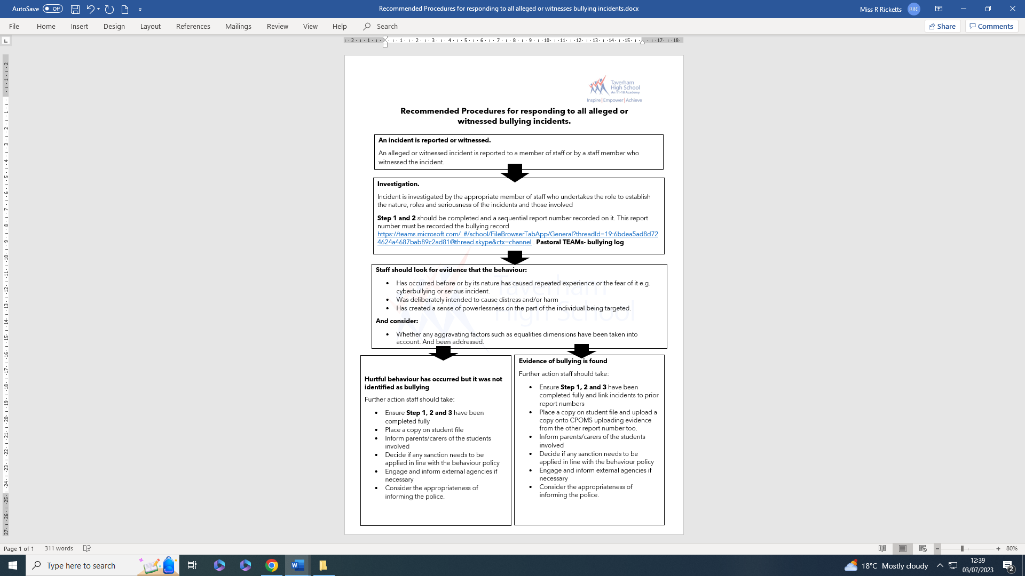

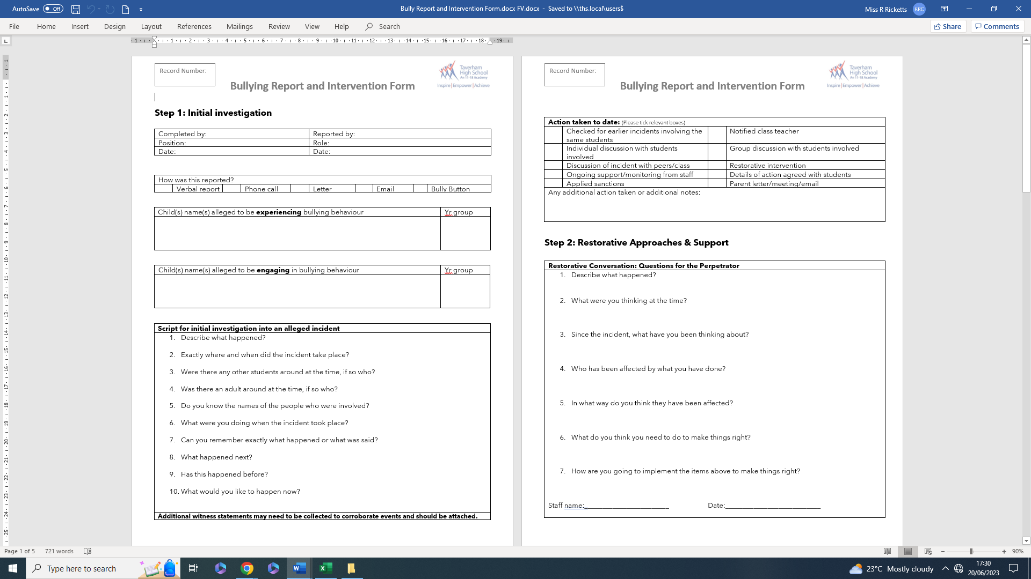



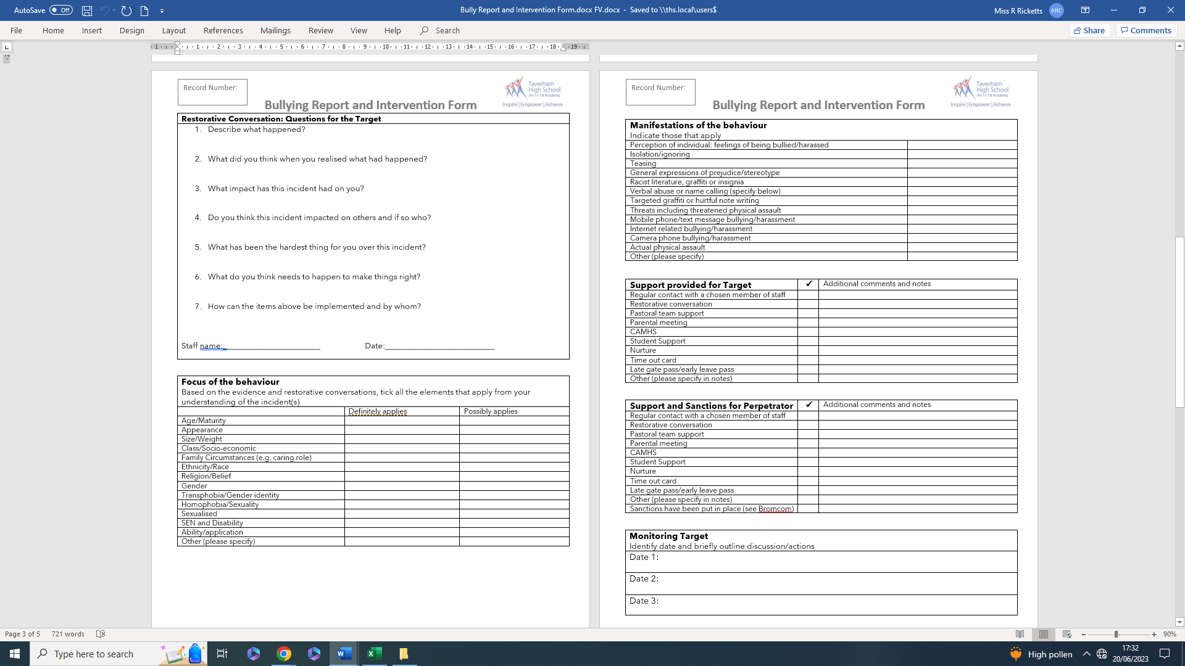



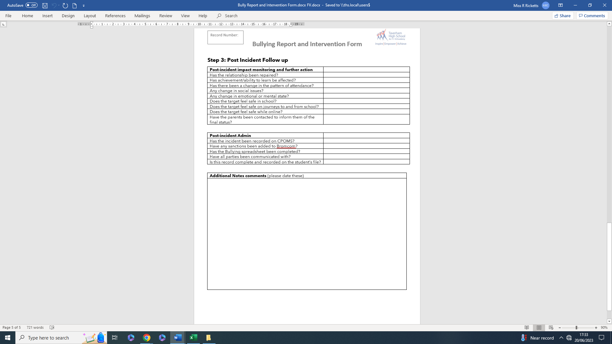

**Appendix 2**

**The following modules are in our PSHE programme**

These units of study enable students to build a greater awareness and understanding which lends itself to the prevention of bullying

|  |  |
| --- | --- |
| **Year 7**  Character development unit  Year 7 Friendships, respect and relationships  Year 7 Health and wellbeing – physical health  Year 7 Health and wellbeing addiction | **Year 8**  Bullying unit of work  Cyber Bullying how to combat bullying online. How to stay safe online: how not to reveal too much information on sites like Facebook. How to deal with cyber stalking and other issues for the police  Year 8 Identity and LGBTQ+ |
| **Year 9**  Year 9 self image  Year 9 PD Mindfulness and mental health | **Year 10**  Year 10: Sexual consent: Greater understanding and awareness lends itself to the prevention of bullying  Grooming |
| **Year 11**  Sex and relationship education: Greater understanding and awareness lends itself to the prevention of bullying | **In addition to PSHE the school will…**  Offer a range of form time activities that address bullying in many forms including:  Use of homophobic language  Instances where transphobic bullying may occur  Prejudiced-based bullying  Mental health  Hold assemblies highlighting prejudice and bullying  Provide a diversity group  Develop and create young people to act as role models such as ELFs and prefects  Provide a range of extra curricular activities that enable our students to be healthy and happy  Offer support and guidance  Workbooks for Inclusion work that address bullying including booklets on racism, homophobia, violence, cyber bullying. |