

Literacy Policy

Application of the policy:

This applies to all staff, students, parents, and relevant stakeholders.

Responsible Staff Member | DTM
Committee to Review | Local Governing Board
Ratification date by Committee | Spring 2026
Review Due | Spring 2029

Definition
Literacy includes speaking, listening, reading and writing. These skills are essential for students to access the curriculum and participate fully in school life. Literacy is therefore the responsibility of all staff across all subjects, not only English teachers.
Literacy Vision
We want all students to develop strong literacy skills that enable them to succeed academically and contribute confidently in the modern world.
Our focus is on embedding effective strategies for:
- Vocabulary development
- Reading comprehension
- Writing for different purposes
- Oracy and learning through talk
These approaches will be consistently applied across the curriculum.
Aims
We aim to ensure every student develops the literacy skills needed for success in school and beyond. Through this policy students will:
- Communicate effectively across the curriculum.
- Develop accurate spelling, grammar and written expression.
- Build a broad and ambitious vocabulary.
- Read with confidence, fluency and understanding.
- Write clearly for different audiences and purposes.
- Plan, draft, edit and improve their writing.
- Engage critically with texts and ideas.
- Speak clearly and listen respectfully in discussion.

Why Literacy Matters
Vocabulary and literacy are key drivers of academic success.
Research shows:
- Up to 90% of vocabulary is encountered through reading rather than everyday conversation (Snow et al., 1998; Stanovich, 1993).
- Teachers improve comprehension when they model expert reading behaviours, such as questioning, predicting and summarising (Rosenshine, 1997; Oakhill et al., 2014).
- Background knowledge improves understanding of texts (Willingham, 2012).
Improving literacy also supports confidence, motivation, behaviour, wellbeing and attainment.
Rationale
At Taverham High School we believe literacy enables students to understand the world, communicate ideas and learn independently. Strong literacy skills empower students and increase their chances of success in education, employment and life.
Our literacy strategy is informed by Education Endowment Foundation (EEF) guidance, particularly the following seven recommendations:
- Prioritise disciplinary literacy across the curriculum
- Provide targeted vocabulary instruction
- Develop students’ ability to read complex texts
- Break down complex writing tasks
- Combine reading and writing instruction
- Provide opportunities for structured talk
- Deliver high-quality literacy interventions
These seven recommendations underpin all the aims, guidance and best practice summarised in this policy. (See Appendix 1).
Disciplinary Literacy
All teachers are teachers of literacy. Each subject has its own specialist vocabulary, ways of reading texts and forms of communication.
Students must learn to read, write and speak like experts within each discipline. Teachers therefore model high standards of spoken and written language and explicitly teach subject-specific literacy.
Our disciplinary literacy focuses on four key areas:
- Vocabulary
- Reading
- Writing
- Oracy
Targeted Vocabulary Instruction
Developing vocabulary is central to improving literacy and attainment.
Teachers will support vocabulary development by:
- Identifying and teaching Tier 2 and Tier 3 vocabulary within subjects.
- Explicitly modelling correct use of academic vocabulary.
- Using knowledge organisers, glossaries and displays.
- Teaching spelling through morphology and etymology.
- Exploring word roots and word families.
- Using strategies such as Frayer models.
- Providing repeated exposure through low-stakes quizzing.
Reading
Students must develop the ability to read increasingly complex academic texts.
Teachers will support reading by:
- Modelling expert reading strategies.
- Teaching students to skim, scan, annotate and summarise texts.
- Providing opportunities for paired and collaborative reading.
- Using questioning to deepen comprehension.
- Encouraging students to make predictions, connections and inferences.
- Ensuring texts provide appropriate challenge.
- Promoting reading for pleasure, including through tutor reading.
Writing
Writing allows students to organise and communicate their thinking. All teachers support writing development.
Strategies include:
- Live modelling of writing using visualisers.
- Sharing and analysing high-quality examples and exemplars.
- Breaking complex tasks into manageable stages.
- Providing sentence starters, writing frames and scaffolds where needed.
- Gradually removing scaffolding to build independence.
- Providing opportunities for planning, drafting and editing.
- Maintaining high expectations for presentation, spelling and grammar.
Oracy
Oracy is the ability to express ideas clearly and engage in meaningful discussion. High-quality classroom talk improves learning and supports disadvantaged students.
Teachers support oracy by:
- Providing structured opportunities for discussion and debate.
- Modelling high-quality spoken language.
- Encouraging full-sentence responses.
- Using sentence stems to support discussion.
- Challenging and extending student thinking through questioning.
- Encouraging students to build on others’ ideas respectfully.
- Providing time for thinking before responses.
The Wider School Environment
Literacy development extends beyond the classroom. We promote a language-rich environment through:
- Staff modelling effective communication.
- Displays of vocabulary and high-quality student work.
- A welcoming and well-resourced school library.
- Reading opportunities during form time.
- Visiting speakers and authors.
- Enrichment activities including theatre visits and literary events.
Supporting Students Who Need Additional Help
Some students require additional literacy support. We identify and support these students through:
- Baseline assessments and assessment data.
- Information from feeder schools and parents.
- Targeted interventions including Bedrock Learning, VIPERS, Paired Reading and Pupil Premium Book Club.
- In-class scaffolding and targeted support.
- Monitoring progress and adjusting support where necessary.
- Assessments for exam access arrangements where appropriate.
Supporting Staff
Literacy development is supported through ongoing professional development.
Staff are encouraged to:
- Develop expertise in disciplinary literacy.
- Share effective practice across departments.
- Engage in CPD focused on literacy strategies.
- Work collaboratively with colleagues and feeder schools.
Roles and Responsibilities
Senior Leaders
- Prioritise literacy within school improvement.
- Monitor the quality and impact of literacy provision.
- Provide training and support for staff.
Teachers
- Embed literacy strategies within their subject teaching.
- Model high standards of spoken and written communication.
- Provide opportunities for reading, writing and discussion.
Form Tutors
- Deliver form literacy activities.
- Support tutor reading programmes.
- Promote respectful discussion and communication.
Librarian
- Maintain an engaging library environment.
- Promote reading for pleasure.
- Support literacy programmes and interventions.
Support Staff
- Reinforce literacy strategies during learning support.
Parents
- Support reading and literacy development at home.
- Communicate with school about concerns.
Students
- Take responsibility for improving their literacy skills.
- Engage with reading and enrichment opportunities.
Governors
- Support the school’s literacy strategy.
- Monitor impact through annual reporting.
Literacy Lead
- Coordinate the school’s literacy strategy.
- Lead literacy CPD and share best practice.
- Support departments in embedding literacy.
- Monitor literacy interventions and impact.
Monitoring and Evaluation
The impact of literacy strategies will be monitored through:
- Lesson observations and learning walks.
- Work scrutiny across subjects.
- Analysis of student progress and intervention outcomes.
Review
This policy will be reviewed regularly by the Headteacher and Governors to ensure it remains effective and aligned with current research and best practice.

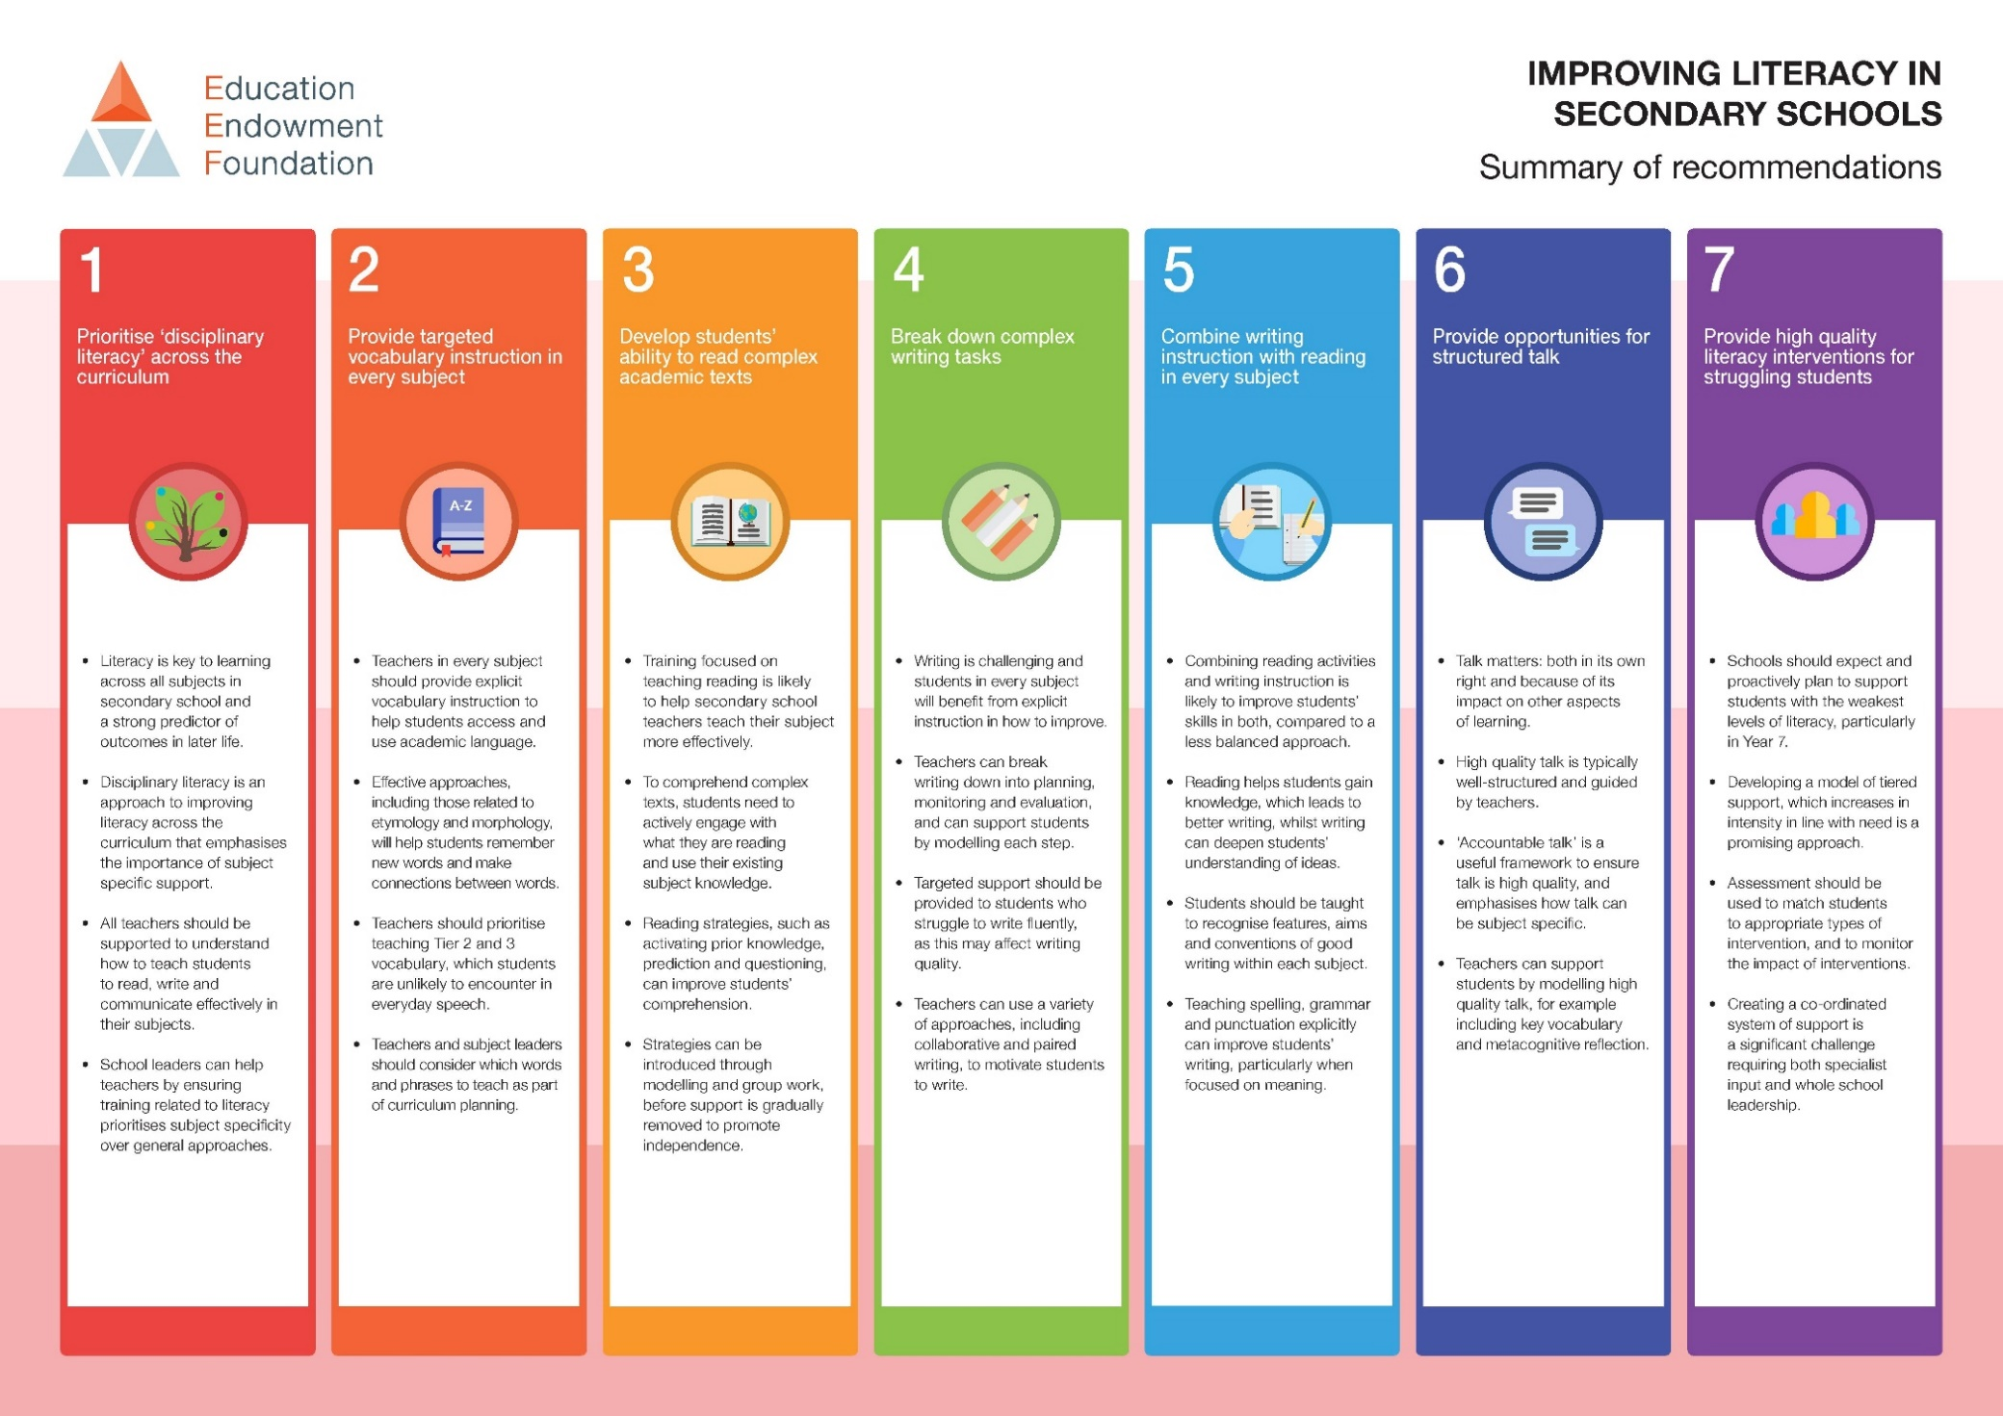
Appendix 1

A summary of disciplinary literacy strategies in class
Vocabulary  - Pre-teach with simple definitions and ask students to chorally repeat back.  - Put into the context of a sentence.  - Break down vocabulary into parts (roots, prefix, suffix) to make links with other vocabulary.  - Use in classroom talk or writing during that lesson.  - Retrieve within the week and again later in the term. Use dual coding. The more the better! | Reading  - Discuss text types and structure – process? information? opinion? Remind students how it is organised.  - As the expert reader in the room, read the text to the students. Ask them to just listen.  - Ask students to follow along during the second reading. Model strategies to them such as summarising, clarifying, predicting, and questioning.  - Dual code key ideas in the text.  - Respond to the text.
Classroom Talk  - Plan why you want students to talk – how will it aid learning? Will it deepen reading comprehension, improve writing or secure learning and recall. Talk needs to be relevant to your subject.  - Embed choral responses in your classroom. This will build confidence & give students their voice back.  - Establish routines linking talk to reading and writing (ready to write).  - Agree on rules for classroom talk. These will need reinforcing until talk becomes part of your lesson.  - Model talk. Make the vocabulary explicit, use sentence stems and model in your teacher talk. | Writing  - Determine what you are writing for. Make the purpose very clear to the students.  - Model using exemplars from reading, expert writing, and student writing.  - Use sentence stems and scaffolds such as structure strips to support writers.  - Use metacognitive strategies to enable students to see where writing is successful and unsuccessful.  - Ensure students can see incremental improvements and they understand why.

Source Material

Didau, D, 2014. Closing the language gap: Building Vocabulary. [online] Available at: https://learningspy.co.uk/literacy/closing-language-gap-building-vocabulary/
Miller, G. and Gildea, P., 1987. How Children Learn Words.
Oxford University Press, 2021. How Schools are Closing the Word Gap. [pdf]. Oxford: Oxford University Press. Available at: https://www.besa.org.uk/wp-content/uploads/2021/11/How-Schools-are-Closing-the-Word-Gap-Oxford-Language-Report-2021-22.pdf
Oxford University Press, No Date. Why Closing the Word Gap Matters: Oxford Language Report. [pdf] Oxford: Oxford University Press. Available at: https://www.oup.com.cn/test/word-gap.pdf
Quigley, A., 2021. Three Pillars of Vocabulary Teaching. The Confident Teacher, [blog] 8 May 2021, Available at: https://www.theconfidentteacher.com/2021/05/three-pillars-of-vocabulary-teaching/
Quigley, A., 2020. Academic Vocabulary and Schema Building. The Confident Teacher, [blog] 7 November 2020, Available at: https://www.theconfidentteacher.com/2020/11/academic-vocabulary-and-schema-building/
The Bell Foundation, 2022. Great Idea: Building Vocabulary. [Online] Available at:
https://www.bell-foundation.org.uk/eal-programme/guidance/effective-teaching-of-eal-learners/
https://www.bell-foundation.org.uk/ eal-programme/guidance/effective-teaching-of-eal-learners/great-ideas/introducing-new-vocabulary/
Teacher Toolkit, 2020. 8 Tips for using subject-specific vocabulary. [online] Available at: https://www.teachertoolkit.co.uk/product/subject-specific-vocabulary/
Woo, N., 2022. Tier 3 vocabulary: 10 top tips for teaching subject-specific terminology. Bedrock Learning, [blog] 9 March 2022, Available at https://bedrocklearning.org/literacy-blogs/tier-3-vocabulary-10-top-tips/
https://assets.publishing.service.gov.uk/government/uploads/system/uploads/attachment_data/file/794355/Research_for_EIF_framework_100419.pdf

Improving Literacy in Secondary Schools Guidance Report, Education Endowment Foundation 2019 – p4
DFE Teachers’ Standards Guidance for school leaders, school staff and governing bodies, July 2011 (introduction updated June 2013)

Beccy Earnshaw, Director Voice 21 in Transform Teaching and Learning Through Talk (Gaunt & Stott, 2019)

Accountable talk is based on knowledge (it seeks to be true), reasoning (providing evidence for opinions), and community (listening and showing respect for others) – from the work of Resnick et al (2018)

