15.12.22

YOUNG PEOPLE FROM TAVERHAM HIGH SCHOOL TRAINED UP TO TACKLE BULLYING
WITH THE DIANA AWARD

On 29.NOVEMBER, 20 pupils will took part in a one-day anti-bullying training session run by The Diana Award at TAVERHAM HIGH SCHOOL. 9 schools from the local area aged between 12 &18, worked together, and acquired vital skills to enable them to change the attitudes and behaviours of bullying in their school by building their skills and confidence to address different situations, both online and off.

The Diana Award’s free Anti-Bullying Ambassador Programme which is available to schools across the UK, sees trainers working with students and other young people to change the attitude surrounding bullying. The programme has a strong peer-to-peer focus, with trainers giving young people the skills and confidence to become Anti-Bullying Ambassadors to tackle bullying in their schools long after the training has finished. The Diana Award’s anti-bullying work is recognised as world-class thanks to this sustainable approach.

The training looked at bullying in different situations including face-to-face and online. At the end of the day, pupils made an action plan of how to approach bullying issues that may arise in their schools and committed to their roles as Anti-Bullying Ambassadors.

Commenting on the training Mrs Killington said, “we are so pleased that we were given the opportunity to host this event for the East of England. It was so lovely to see our students engage in such a brilliant event. We would like to thank the Diana team for a fabulous day”

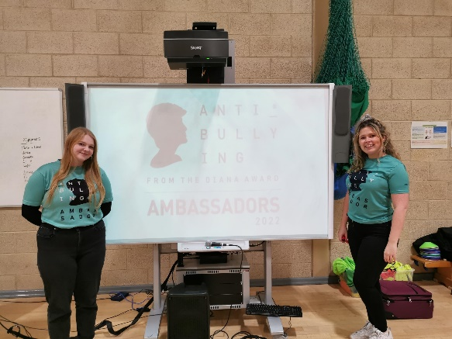

The Diana Award Anti-Bullying Ambassador programme run by the charity, The Diana Award. The Diana Award was founded as a legacy to Diana, Princess of Wales’ belief that young people have the power to change the world for the better. Its mission is to foster, develop and inspire positive change in the lives of young people.

Social Media:
@DianaAward @AntiBullyingPro
Fb.com/thedianaaward fb.com/antibullyingpro

